10 x 10: Extensor Tendon Injuries: More Than Just the Mallet
Oct 21, 2020
Kelly Huang
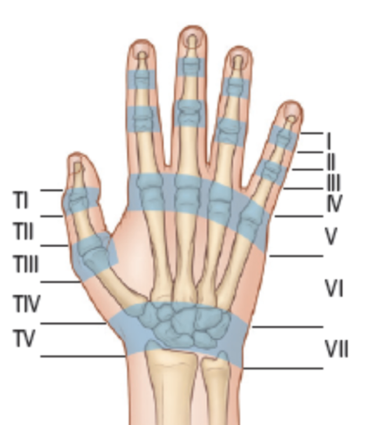
Anatomy:
Zone | Area | Structure injured | Deformity
I | DIP joint | Terminal tendon | Mallet
II | Middle phalanx | Lateral slips | Mallet
III | PIP joint | Central slip | Boutonnière
IV | Prox phalanx | Central slip
V | MCP joint | EIP | Fight bite
VI | Metacarpals | EDC
VII | Retinaculum
Assessment:
- Physical exam:
  - Neurovascular check first – fine touch, pin prick, +/- two point discrimination
  - Then immediately ring block so rest of physical exam is reliable
  - Check active ROM against slight resistance
    - If able to – partial laceration – no need for repair
    - If unable to ROM against resistance – full laceration – needs repair
- Elson’s test
  - Restrict PIP joint to 90 degree flexion
  - Assess active extension against slight resistance
  - If distal phalanx remains soft, then it is normal
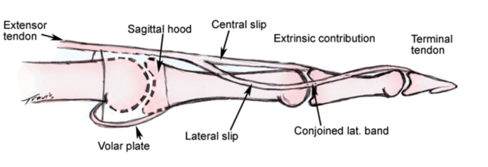
  - Checks central slip injury – if central slip is fully lacerated, distal phlanx would be firm or they would be unable to extend
Management
- Zone 1 – 3 should be repaired by plastics
- Zone 4 – 7 can be repaired by EPs
- Partial (<50%) laceration – conservative management, splint x 4 -6 weeks
- Full (>50%) laceration – core sutures and splint 6 – 8 weeks
- Everyone needs a volar slab in full extension and sent to hand clinic
- Core suturing – modified Kestler youtube video starting at 4:56
  - The tendon has many rope-like strands and therefore simple interrupted stitches would not hold against tension
  - Big bites! ~ 1cm on each stump
  - Non absorbable sutures – ethilon, nylon, as large as the tendon can tolerate, usually 3-0
Specific Injuries:
- Mallet: if closed, splint DIP (leaving PIP and MCP free) and send to hand clinic
- Boutonniere: splint PIP (leaving DIP and MCP free) and send to hand clinic
- Fight bite: suspect in everyone with zone 5 lacerations!
  - 25% get infected, needs irrigation and exploration, call plastics!
  - Amox clav for strep/staph coverage, do not close the skin

