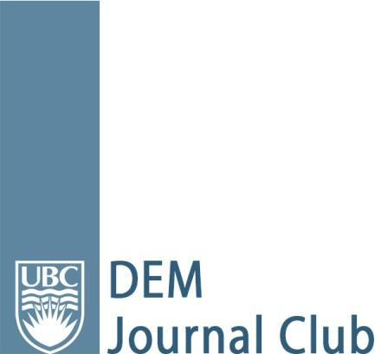
Article Appraisal
Article: Diagnosing acute aortic syndrome: a Canadian clinical practice guideline
Date of Journal Club: December 15, 2020
Resident Reviewer Name(s) and Residency Affiliation: Zamé Engelbrecht, PGY3 (CCFP-EM)
Faculty Methodology/Bio-statistics Resource Person: Dr. Andrew Kestler

Background and Study Objective(s):
Acute aortic syndrome (AAS) is a spectrum that includes aortic dissection, intramural hematoma and atherosclerotic ulcer. The exact prevalence in the ED population is unknown, but has been estimated to be about 1 in 2000 presentations of acute chest or back pain. There are significant diagnostic challenges and consequently the initial visit misdiagnosis rate is up to 38%. Additionally, investigation for AAS in Canada is highly variable.
This clinical practice guideline aims to update available recommendations with new evidence, interpret the evidence in the context of values and preferences, and make practical recommendations that are applicable to the Canadian health care system.

Study Design:
The guideline development team consisted of 21 ER physicians, nurses, other specialists, and patients across Canada. The committee used the GRADE (Grading of Recommendations, Assessment, Development and Evaluations) approach to adapting existing guidelines and formulating new recommendations, using an iterative process. None of the committee members had identified conflicts of interest.
The team then prioritized key clinical questions which formed the groundwork for developing their recommendations. First, they asked what the optimal test threshold would be for different pre-test probabilities. To answer this they conducted a national survey of physicians and determined an “acceptable miss rate” of <1%. In addition, through panel discussion they decided on low <0.5%, moderate 0.5-5% and high >5% pre-test probabilities.
Next, they conducted systematic reviews to estimate the prevalence of acute aortic syndrome and the diagnostic accuracy for various signs, symptoms and investigations for AAS. They estimated the prevalence of AAS to be about 2%, Using this as well as the pre-determined testing thresholds, they performed Bayesian modelling to calculate the test accuracy of various combinations of signs, symptoms and tests. This ultimately led to their recommendations which were revised until consensus was achieved and then reviewed by key stakeholders.

Results:
The results of this paper were laid out in recommendations for the diagnosis of acute aortic syndrome in the ED. These are compiled into easy-to-follow clinical decision aids.
The first recommendation concerns the assessment of pre-test probability in any patients whose complaints may represent AAS. This is achieved through asking specific questions regarding risk factors, pain features and physical exam findings. Next, this information is used to define the pre-test probability of AAS using the provided clinical decision aid.
The next recommendation outlines suggested diagnostic strategies for each low, moderate and high pre-test probabilities (PTP.) For low PTP, no further testing is suggested. For moderate PTP, the committee suggest first starting with a D-Dimer assay. If the value is <500ng/nl, then the investigation stops. If the D-dimer is positive, then an ECG-gated CT aorta is recommended. For high PTP, the committee advises against the use of D-Dimer, and instead recommends moving directly to an ECG-gated CT aorta. If this is not feasible, then MRI or TEE are possible alternatives.
Of note, these recommendations do not apply to pregnant patients, those who used cocaine in the last 24 hours, or patients <18 years old. In addition, ECG-gated CT aorta is recommended as the gold standard, as it avoids motion artifact.

Validity of Results:
The recommendations in this clinical practice guideline add to the existing American and European guidelines by incorporating new evidence on risk factors (such as abdominal aortic aneurysms) and the roles of D-Dimer. Due to a paucity of high-quality existing literature, the recommendations are based largely on very low or low quality of evidence, as well as on modelled estimates of disease prevalence and test accuracy. Prospective studies are still needed to validate the use of the clinical decision aid.

Generalizability of Results:
The recommendations in this guideline are aimed at the Canadian population. The committee took into account both physician and patient preferences when formulating the guidelines. In addition, the draft was reviewed by more than 300 ER physicians, radiologists and vascular surgeons across the country, as well as key stakeholder organizations like CAEP.
These recommendations are aimed to standardize the diagnostic workup for AAS regardless of where patients present in Canada. In a survey following release of the recommendations, some clinicians felt that the guidelines would support their clinical decision-making, and had the potential to reduce resource use, especially in rural settings.

The Bottom Line:
These first-ever Canadian clinical practice guidelines provide recommendations for risk-stratification and diagnostic strategies for patients presenting with symptoms that could be AAS. The authors compile the existing evidence and constructed a nuanced approach to determining pre-test probability using features from the history and physical exam. Future studies are needed to determine whether this clinical decision aid can capture those patients who lack the textbook presentation of AAS and might otherwise be missed on their initial visit.

