ROTEM for Trauma
The Basics

- Trauma-induced coagulopathies are a significant cause of mortality in trauma patients. 25-35% of severely injured trauma pt's have already developed a TIC prior to arriving in the ED which confers significant mortality.

- Standard lab tests were developed for monitoring therapeutic anticoagulation, not expeditious identification of trauma-related coagulation defects. They do not reflect clot quality or stability and they cannot be used to monitor coagulopathy

- ROTEM is a Viscoelastic Hemostatic Assay which measures the global properties of whole-blood clot formation in real time. It is a rapid point-of-care test that allows for dynamic monitoring and guides focused treatments.

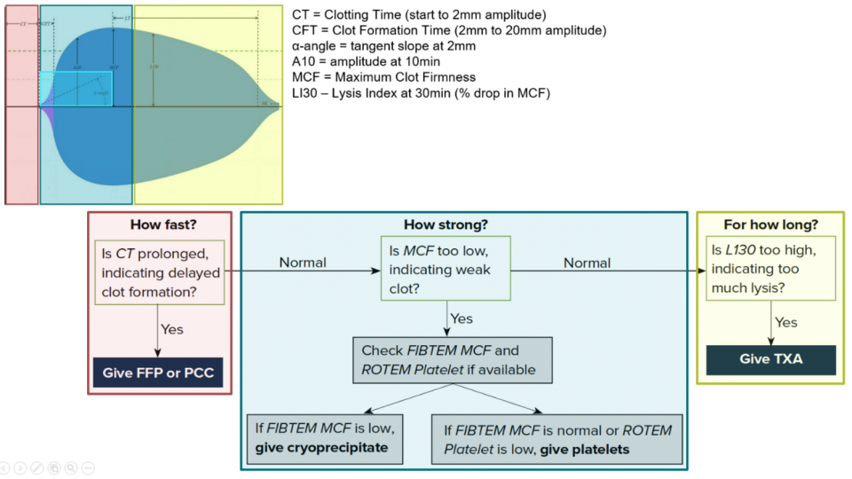
- Interpreting ROTEM can be complicated but is made simpler by asking the three questions
  - How fast?
  - How strong?
  - How long?

- Although evidence for There is growing evidence that application of ROTEM‐guided transfusion strategies may reduce the need for blood products and improve morbidity in patients with bleeding.
References

- Brohi K, Singh J, Heron M, Coats T. Acute Traumatic Coagulopathy. J Trauma 2003; 54: 1127-30. https://www.ncbi.nlm.nih.gov/pubmed/12813333
- https://emottawablog.com/2020/09/rotem-in-trauma-blood-is-thicker-with-wine-part-1-the-evidence/
- https://emottawablog.com/2020/09/rotem-in-trauma-blood-is-thicker-with-wine-part-2/
- SaraÃ§oÄlu A, Yarat A, Tetik S. The role of viscoelastic tests in trauma: TEG and ROTEM. J Pharmacol Med Chem 2017;1(1):1-5. https://www.pulsus.com/scholarly-articles/the-role-of-viscoelastic-tests-in-trauma-teg-and-rotem-3563.html
- Prat NJ, Meyer AD, Ingalls NK, Trichereau J, DuBose JJ, Cap AP. Rotational thromboelastometry significantly optimizes transfusion practices for damage control resuscitation in combat casualties. J Trauma Acute Care Surg. 2017 Sep;83(3):373-380. doi: 10.1097/TA.0000000000001568. PMID: 28846577; PMCID: PMC7350930.
- Kauvar DS, Lefering R, Wade CE. Impact of Hemorrhage on Trauma Outcome: An Overview of Epidemiology, Clinical Presentations, and Therapeutic Considerations. J Trauma 2006; 60: S3-11. https://www.ncbi.nlm.nih.gov/pubmed/16763478.
- https://litfl.com/thromboelastogram-teg/
- https://www.emra.org/emresident/article/teg-and-rotem/
- Wikkelsø A, Wetterslev J, Møller AM, Afshari A. Thromboelastography (TEG) or thromboelastometry (ROTEM) to monitor haemostatic treatment versus usual care in adults or children with bleeding. Cochrane Database of Systematic Reviews 2016, Issue 8. Art. No.: CD007871. DOI: 10.1002/14651858.CD007871.pub3.
- https://www.rotem.de/en/methodology/rotem-delta-and-sigma-analysis/

