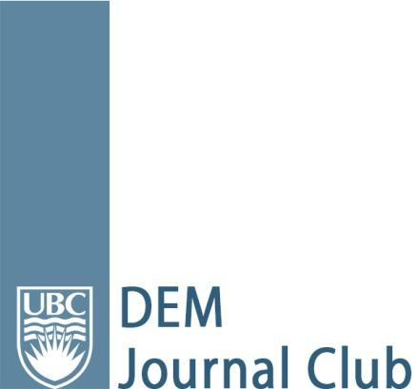
Article Appraisal

Article: Dankiewicz J et al. Hypothermia versus Normothermia after Out-of-Hospital Cardiac Arrest. NEJM 2021; 384; 24: 2283-2294.

Date of Journal Club: September 21, 2021
Resident Reviewer Name(s) and Residency Affiliation: Kiran Rikhraj (Vancouver, PGY-3) and Kerry Spearing (Interior, PGY-4)
Faculty Methodology/Bio-statistics Resource Person: Dr Frank Scheuermeyer

Background and Study Objective(s): This study aims to determine the benefits and harms in inducing hypothermia versus maintaining normothermia and treating fever in out-of-hospital cardiac arrest (OHCA) patients.
Study Design: International, multicentre, randomized controlled trial.
Methods: The trial included 1861 adult patients admitted 61 institutions in 14 different countries between November 2007 and January 2020 after OHCA of a presumed cardiac or unknown cause, irrespective of the initial rhythm. Patients had to have more than 20 consecutive minutes of return of spontaneous circulation (ROSC), be unconscious, not obey verbal commands, and not have a verbal response to pain. Patients with ROSC of more than 180 minutes prior to screening, unwitnessed cardiac arrest with asystole as the initial rhythm and limitations in care were excluded. Patients were randomized in a 1:1 ratio to undergo hypothermia at 33C for 28 hours or to maintain normothermia at 37.5C with cooling if temperature reached >37.8C. Primary outcome was death from any cause at 6 months. The main secondary outcome was poor functional outcome at 6 months (mRS of 4-6). An intention-to-treat analysis was performed using multiple logistic regression.
Results: At 6 months, 50% of patients in the hypothermia group and 48% of patients in the normothermia group had died with a relative risk of 1.04 (95%CI 0.94-1.14; p=0.37). Relative risk of poor functional outcome in the hypothermia group versus normothermia group was 1.00 (95%CI 0.91-1.08). Arrhythmias resulting in hemodynamic compromise were significantly more common in the hypothermia group (24% versus 17%, p<0.001).
Validity of Results: The study had a focused question, robust sample size, patient-centered outcomes, near complete follow up, minimal deviations from the protocol and high internal and external validity. The lack of mortality benefit to inducing hypothermia was noteworthy.
Generalizability of Results: The patients are likely similar to those in Canadian centers.
Limitations: Clinicians who made decisions on withdrawal of life support were unblinded to the intervention, the trial did not include in-hospital cardiac arrest patients or OHCA patients with a clear non-cardiac cause of arrest, and 20% of patients were concurrently enrolled in the TAME trial, which could have confounded the results.
The Bottom Line: Induction of hypothermia in OHCA patients with a presumed cardiac or unknown cause of arrest does not show mortality benefit or an improvement in functional outcomes at 6 months compared to maintaining normothermia and treating fever. Thus, it is reasonable to aim for normothermia in these patients. Further studies are needed to assess if there is benefit to any temperature management versus no temperature management.

